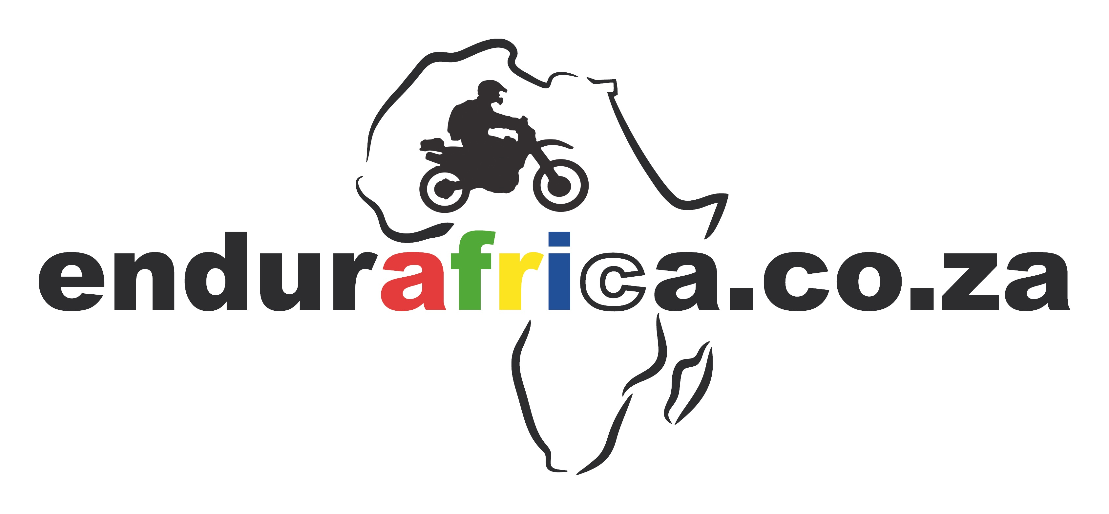
DECLARATION OF MEDICAL CONDITION

The information contained in this declaration is confidential and strictly limited to the use in combination with off-road motorbike tours organised by endurafrica Pty. Ltd.
By accepting this, endurafrica Pty. Ltd. agrees that it will keep strictly confidential all information and will not use it, or permit it to be used by any other person without the consent of the parties concerned.
endurafrica Pty. Ltd. may disclose the confidential information if required to do so by law.
Confidential information does not include information already available to and known to the public.

PERSONAL DETAILS

Name
Surname
ID or Passport #
Street
Postal code
Town | Country
Cell
Email

Off-road motorbiking is a physically and to a certain extend mentally demanding activity.

Therefore, participants should be unaffected by any medical condition that may prevent them from riding safely on technical terrain and in hostile environment.

Please tick the appropiate box(es) if you are knowingly affected, to the best of your knowledge and belief, by one of the following conditions:

Prescribed medication
Alcohol or drug dependence
Diabetes, high or low blood sugar
Epilepsy, fits or periods of unconsciousness, e.g. blackouts
Vertigo, giddiness or difficulty with balance
Musculoskeletal issues, e.g. chronical back pain
Psychiatric illness
Sensory impairment, e.g. blind, deaf
High or low blood pressure
Impaired limb function
Other

Or

I am in good health and not knowingly affected by one of the above conditions

If a participant has a contra-indicated condition (listed above or otherwise), endurafrica strongly recommends that he/she should obtain a certificate from a medical doctor to confirm that the condition does not prevent that person from attending an off-road motorbike tour.

By signing this declaration, you warrant and acknowledge that:

• the information given by you in entering this declaration is correct and will be relied upon by us

• endurafrica staff is not medically qualified and should you have any concerns regarding your health and/or fitness you should seek independent medical advice before engaging in any physical activity such as off-road motorbiking

• members of the endurafrica staff have the right to exclude any participant from riding if they have concerns over his/her health, fitness or attitude to safety

• to the best of your knowledge and belief, you are in good health to perform off-road motorbiking, and that such activitiy would not be detrimental to your health, wellbeing or physical condition

• you will advise endurafrica should your health deteriorate or your vulnerability to injury change during a tour

• should there be any contra-indication or doubt regarding health or fitness to perform off-road riding, a medical certificate has been provided as confirmation

Please tick this box if a medical certificate has been provided

Comments

Completed and signed declaration to be sent back to: info@endurafrica.co.za

Date: Signature:

